The Bailey Practice
Comely Bank Clinic, 46 Ravenswood Road, E17 9LY
Tel: 020 8520 5138 Fax: 020 8509 0532
Website: www.thebaileypractice.co.uk
Email: nelondonicb.baileypractice@nhs.net

General Practitioners: Dr Jennifer Bailey, Dr Zoe Bailey
Nurse Practitioner: Ms Elizabeth Bailey
Practice Nurse: Esha & Faiza
Practice Manager: Ash
Receptionists: Hilary, Gemma, Venesha & Frances

Opening Times
The surgery reception is open from 08:00-18.30pm Monday – Friday.

Consultation Times
We have made some changes to our services to ensure that we are able to continue delivering safe and effective care.
Face to face appointments are available to all our patients, but you will be asked to discuss your conditions over the phone or online using our online e-consult service first to assess what would be most appropriate for you.
Making an Appointment
- By calling the surgery on 0208 520 5138
- online using our online e-consult service
The Doctors and the Advanced Nurse Practitioner are happy to speak to patients on the telephone.
If you require a doctor outside these hours please ring 0208 519 3999 or NHS 111.
Enhanced out of Hours Services

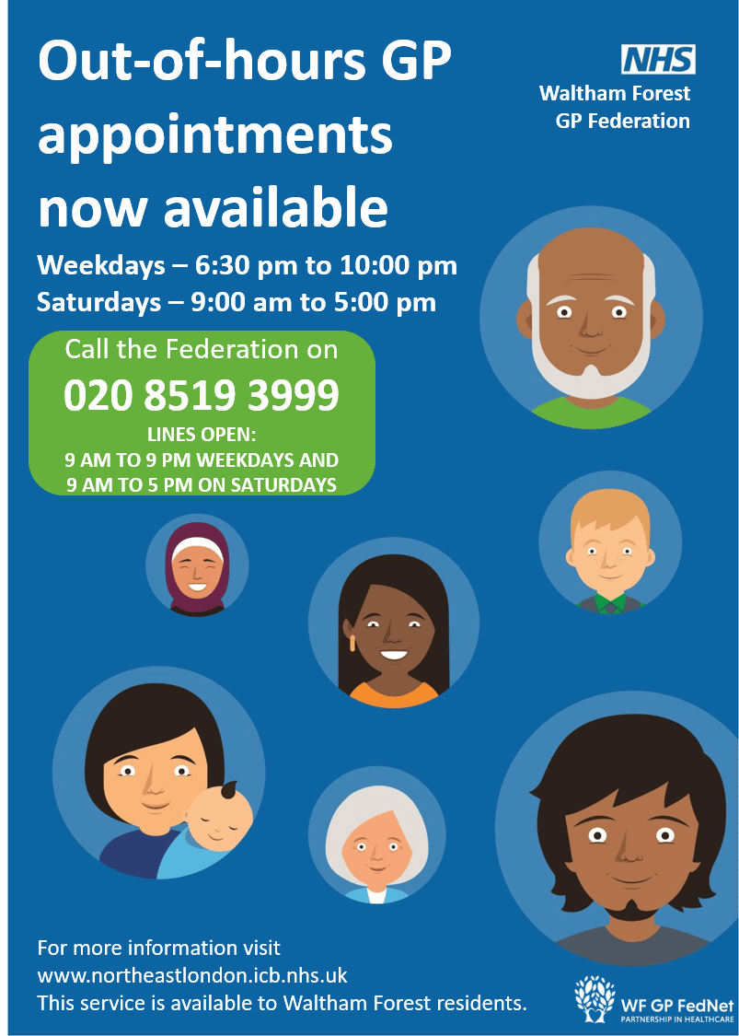

Repeat prescriptions

Please note we no longer accept prescription requests over the phone or via email.
There are 3 ways to order a repeat prescription.
- NHS App - https://www.nhs.uk/nhs-app/
- Contact your local pharmacy and ask to set up a repeat prescription service with them. You will need to inform them that you are registered at our practice and give them a list of your medication. We will send the prescriptions to them for you to collect.
- Send us a written request with a stamped envelope enclosed, we will then send your prescription back to you in the pre-paid envelope.
*We require 48 hours’ notice in order to process your repeat prescriptions.

Registration
We are an open list and are taking new patients please enquire at reception for details.

Services Available
The doctors and advanced nurse practitioner are able to advice on any medical issue, and if necessary will refer you to secondary care specialists as well as appropriate community services.
Patient Feedback
The Bailey Practice would like to improve patient care and services. If you feel there is any aspect of the service that we could improve on you are encouraged to speak to the acting practice manager Ash Henson or leave a note in our suggestion box.

Rights and responsibilities
We respect the rights of our patients in terms of race, gender, social class, age, religion, sexual orientation, disability or medical condition and would expect the same from our patients. The practice follows a strict policy of confidentially at all times all information is protected and shared and shared only with the patient concerned.
Visits
If a house call is needed please telephone the surgery in the morning and a clinician will talk to you.
Test Results
The surgery will contact you if your results require follow up and treatment. If you want to discuss a particular result please call between 11:00-12:00 or 16:00-17:00 to book a routine appointment with a clinician.
Complaints
If you have any comments or complaints, please contact the surgery on 02085205138 to discuss with Dr Jennifer Bailey.
If you wish to put your comments/complaints in writing which can be handed in to the surgery or sent via post.
From 1 July 2023 the way members of the public make a complaint about primary care services to the commissioner is changing. Rather than contacting NHS England, you will contact your local integrated care board (ICB)
You can do this by:
Telephone: 020 8221 5750
E-mail: nelondonicb.complaints@nhs.net
Writing to them at:
Complaints Department
NHS North East London
4th Floor – Unex Tower
5 Station Street
London E15 1DA

If you are still dissatisfied you can complain to the ombudsman, Parliamentary and Health Service Ombudsman, Millbank Tower, London SW1P 4QP. Tel: 0345 015 0433 or fax: 0300 061 4000 or visit www.ombudsman.org.uk

